Cats and Dogs Image Classification Using Deep Learning with Python

Python Implementation of CNN Model using Keras and TensorFlow is available on [**GitHub**](https://github.com/ChaithanyaVamshi/Image-Classification-CNN)

# **CNN Neural Network Model Accuracy Results on Training and Validation Data**

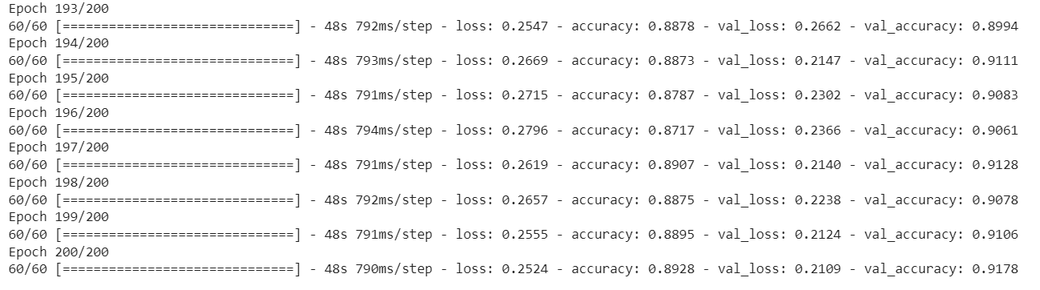

**Results:**

60/60 - 41s 681ms/step - loss: 0.2243 - accuracy: 0.9040

**Training Accuracy: 90.40%**

18/18 - 5s 273ms/step - loss: 0.2109 - accuracy: 0.9178

**Validation Accuracy: 91.78%**

* We can observe that the model accuracy of the **Training data** is 90.40% and the **validation data** is **91.78% (≈92%)** after 200 epochs.
* The validation accuracy is slightly greater than the training accuracy in almost every training. That means that our model doesn't overfit the training set.
* Hence, we can say that our Convolutional Neural Network (CNN) model is more **generalized** and prevented overfitting.

# **CNN Model Architecture Summary**

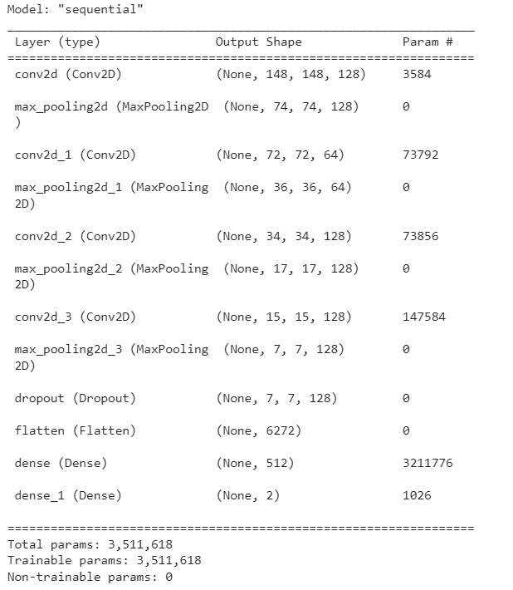

# **CNN Model Loss on Train and Validation Data**

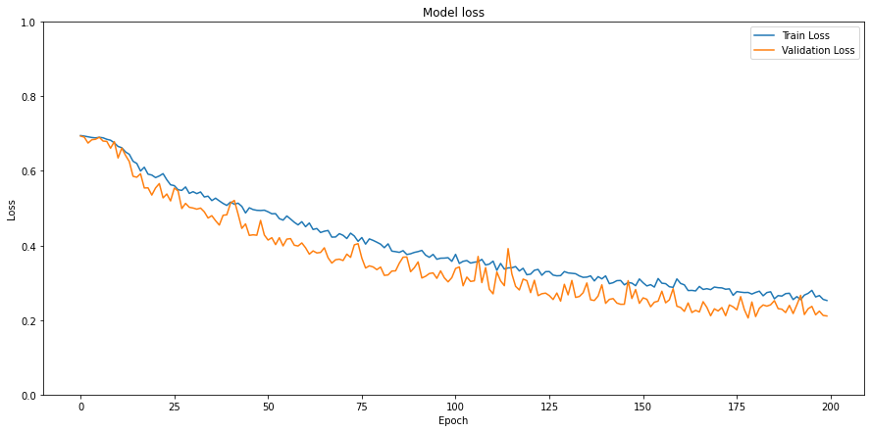

# **CNN Model Accuracy on Train and Validation Data**

